COURSE: CLOUD AND NETWORK SECURITY _C1-2024

STUDENT NAME: LENNIE NTHIGA
STUDENT NO: cs-cns07-24170
OCTOMBER 9,2024

WEEK 4 ASSIGNMENT 1
Assignment 1: VLANs and Secure Switch Configuration

Contents
INTRODUCTION 3
Setting up a network 3
Configuration of the network 4
Configuration of switches 5
Configure VLANs on Switches. 5
Configure the SVI for VLAN 10. 5
Configure VLAN 333 with the name Native on S1 and S2. 5
Configure Switch Security. 7
Step 1: Implement 802.1Q trunking. 7
Step 2: Configure access ports. 7
Step 3: Secure and disable unused switchports. 7
Step 4: Document and implement port security features. 8
Step 5: Implement DHCP snooping security. 9
Step 6: Implement PortFast and BPDU guard. 9
CONCLUSION 10

INTRODUCTION
In many organizations they have different departments making the implementation of network infrastructure grow to larger scales and in a distributed all over thus making the accessing of the physical devices more reachable and one can plug in any attacking device and access the network however by securing these ports in tehri command can be useful rather than monitoring the devise physically which can be difficult

Setting up a network
By having a router R1 connected to a switch S1 using ethernet cable to a computer PC-A
We connected switch S1 to switch S2 using Ethernet cable and S2 to computer PC-B using Ethernet cable
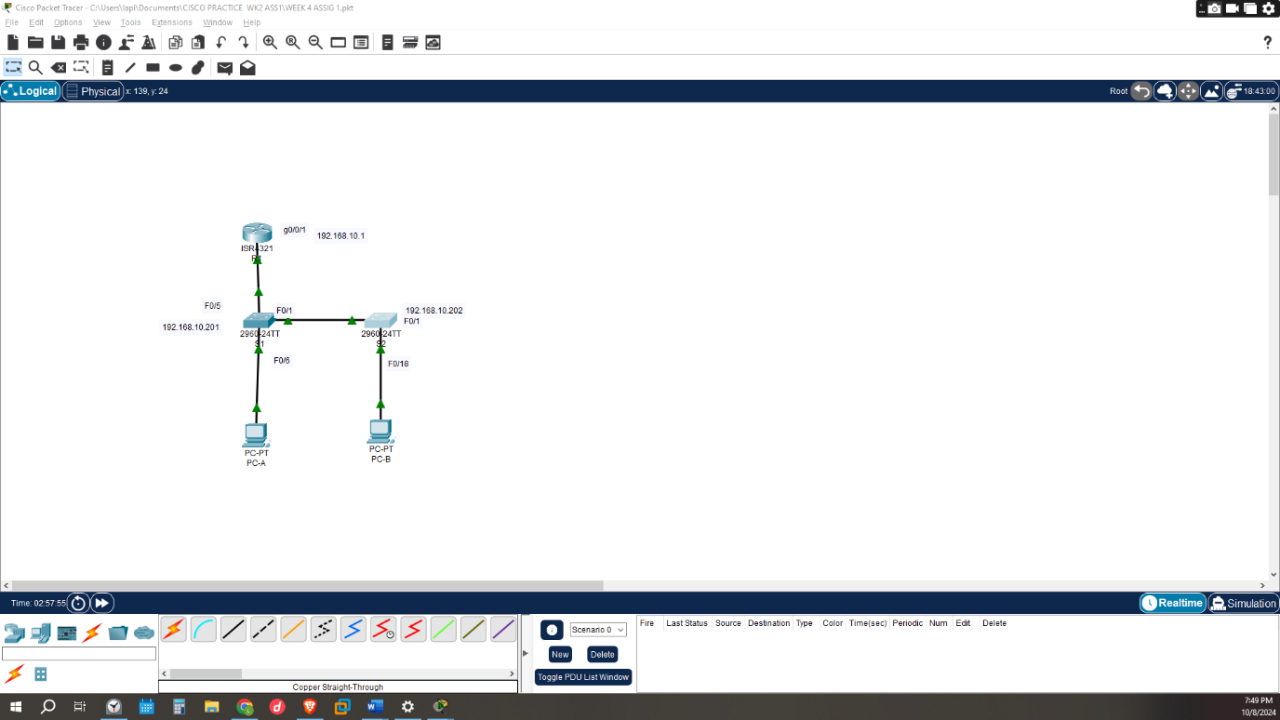

Configuration of the network
This time we would be configuring the pcs assigning them Ip addresses using dhcp
- We would exclude some ips for the purpose of allocating them as gateways thus
Ip dhcp excluded-address 192.168.10.1 192.168.10.9
Ip dhcp excluded-address 192.168.10.201 192.168.10.202
- Would be created A dhcp pool which specifies the network subnet mask 192.168.10.0 255.255.255.0 under name students with a default gateway 192.168.10.1 for clients to get Ip address .The domain secure.com would be used to provide a domain name to clients that receive their IP address from the DHCP server instead of remembering the Ip address of the network’s resources
- The interface Loopback0 being assigned 10.10.1.1 255.255.255.0 would be setup for testing purposes in that Packets sent to this address never reach the network but are looped through the network interface card only. This can be used to verify that the internal path through the TCP/IP protocols is working.
- Setting up interface GigabitEthernet0/0/1 with the Ip 192.168.10.1 255.255.255.0 where it links switch S1
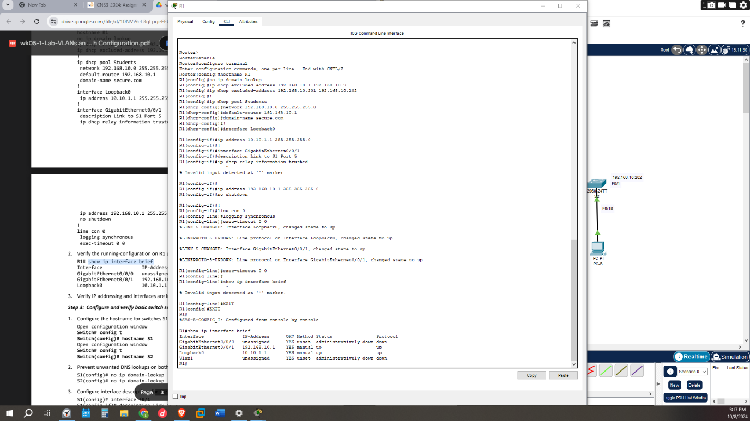

Configuration of switches
- no Ip domain-lookup command would be used to disable DNS lookup in that when one types a command and it not recognizable typo if not disabled the DNS would attempt looking it up .thus disabling would help in producing an error if so and help when one Is using command frequently
- Configure interface descriptions for the ports that are in use in S1 and S2.
- Setting up the default-gateway for the Management VLAN to 192.168.10.1 on both switches.
Noticing that S1 and S2 clan gateways are the same to the gateway of the router on interface G0/0/1

Configure VLANs on Switches.
VLAN is a group of network devices (computers, servers, and other resources) that behave as if they are connected to a single network segment, even though they might not be e.g. in a n organization there is a department of finance in which they share same sources and bandwidth but in the same organization there’s a dept of marketing that would share resources without either of the two seeing/accessing each other’s resources thus invisible to the other.
Management VLAN-is a much smaller network that is contained within your regular network used specifically for managing network devices thus separates management traffic from user data traffic.
- Add VLAN 10 to S1 and S2 and name the VLAN Management.

Configure the SVI for VLAN 10.
SVI -Switched Virtual Interface is a logical interface configured on a layer 3 switch that connects a VLAN to the routing engine of the switch thus allows traffic to be routed between VLANs by providing a default gateway for each VLAN.
- Both S1 AND S2 have interface VLAN 10 but the Ip address of VLAN 10 for S1 would be 192.168.10.201 255.255.255.0 while S2 is 192.168.10.202 255.255.255.0
- Adding their descriptions as Management SVI

Configure VLAN 333 with the name Native on S1 and S2.
Native VLAN – is used for takes care of frames that lack an assigned VLAN membership, effectively managing untagged traffic. Thus, the Native VLAN is the one VLAN which traverses a Trunk port without a VLAN tag.
Trunk port - is a specific port on a switch configured to transmit data traffic for multiple VLANs (Virtual Local Area Networks) by encapsulating the traffic with unique VLAN tags. They are essential for inter-switch links that connect multiple switches together.
Access port- can have only one VLAN configured on the interface thus carry traffic for only one VLAN.
ParkingLot - refers to a VLAN designed to hold unused or inactive ports, that are not assigned to any specific VLAN for regular user access.
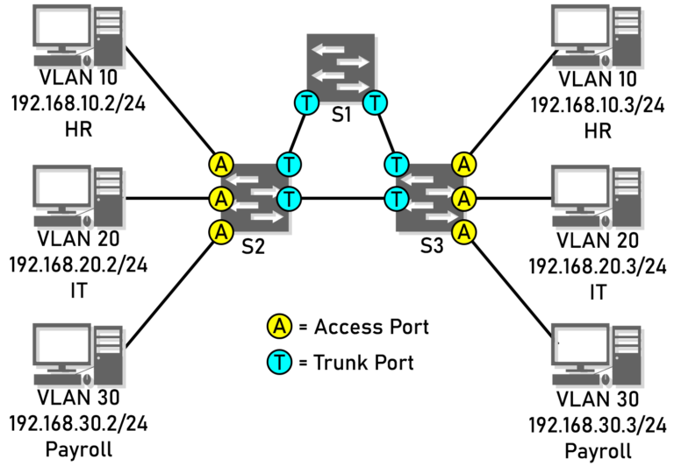
When frames traverse a Trunk port, a VLAN tag is added to distinguish which frames belong to which VLANs. Access ports do not require a VLAN tag, since all incoming and outgoing frames belong to a single VLAN. The Native VLAN is simply the one VLAN which traverses a Trunk port without a VLAN tag.
- VLAN 333 being assigned as the native is the one VLAN which traverses a Trunk port without a VLAN tag.
- VLAN 999 being assigned as parking lot would be used for the purpose of any traffic that is not explicitly tagged with a VLAN ID will be treated as belonging to VLAN 999
.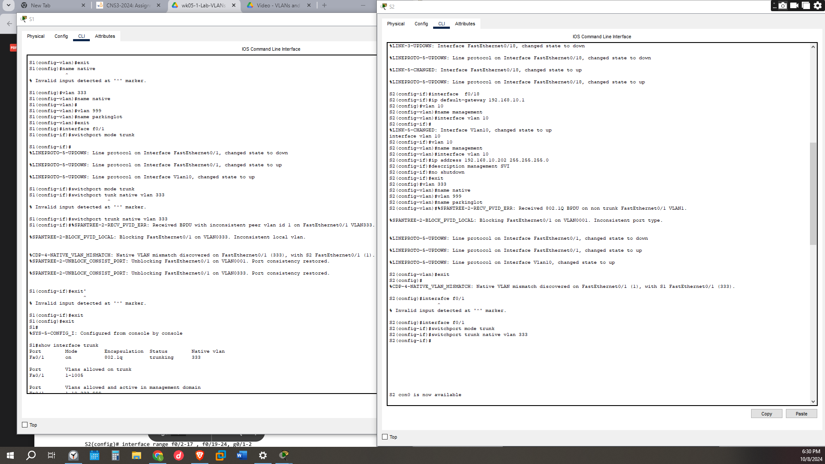

Configure Switch Security.

Step 1: Implement 802.1Q trunking.
802.1Q – (protocol)is networking standard that supports (VLANs) Ethernet network inserts a tag into the Ethernet frame to identify which VLAN the frame belongs to and the accompanying procedures to be used by bridges and switches in handling such frames.
802.1Q trunking is a networking standard that allows multiple VLANs to be transmitted over a single physical link between switches, routers, or other network devices.
- On both switches S1 and S2 we would configure trunking on F0/1 to use VLAN 333 as the native VLAN. Bu using
switchport mode trunk
switchport trunk native VLAN 333
- Disable DTP negotiation on F0/1 on S1 and S2.
-DTP is Dynamic Trunking Protocol - is a proprietary link layer protocol developed for the purpose of negotiating trunking on a link between two VLAN-aware switches, and for negotiating the type of trunking encapsulation to be used.
- Verify with the show interfaces command.

Step 2: Configure access ports.
Access port- can have only one VLAN configured on the interface thus carry traffic for only one VLAN. These switch ports are connected with devices such as end user devices within a specified VLAN
- On S1, configure F0/5 and F0/6 as access ports that are associated with VLAN 10.
interface range f0/5 – 6
switchport mode access
switchport access VLAN 10

Step 3: Secure and disable unused switchports.
- On S1 and S2, move the unused ports from VLAN 1 to VLAN 999 and disable the unused ports.
interface range f0/2-4 , f0/7-24, g0/1-2
switchport mode access
switchport access VLAN 999
shutdown
- Verify that unused ports are disabled and associated with VLAN 999 by issuing the show command.
All this can be viewed in the screenshot which ports have been disabled and which are allocated.

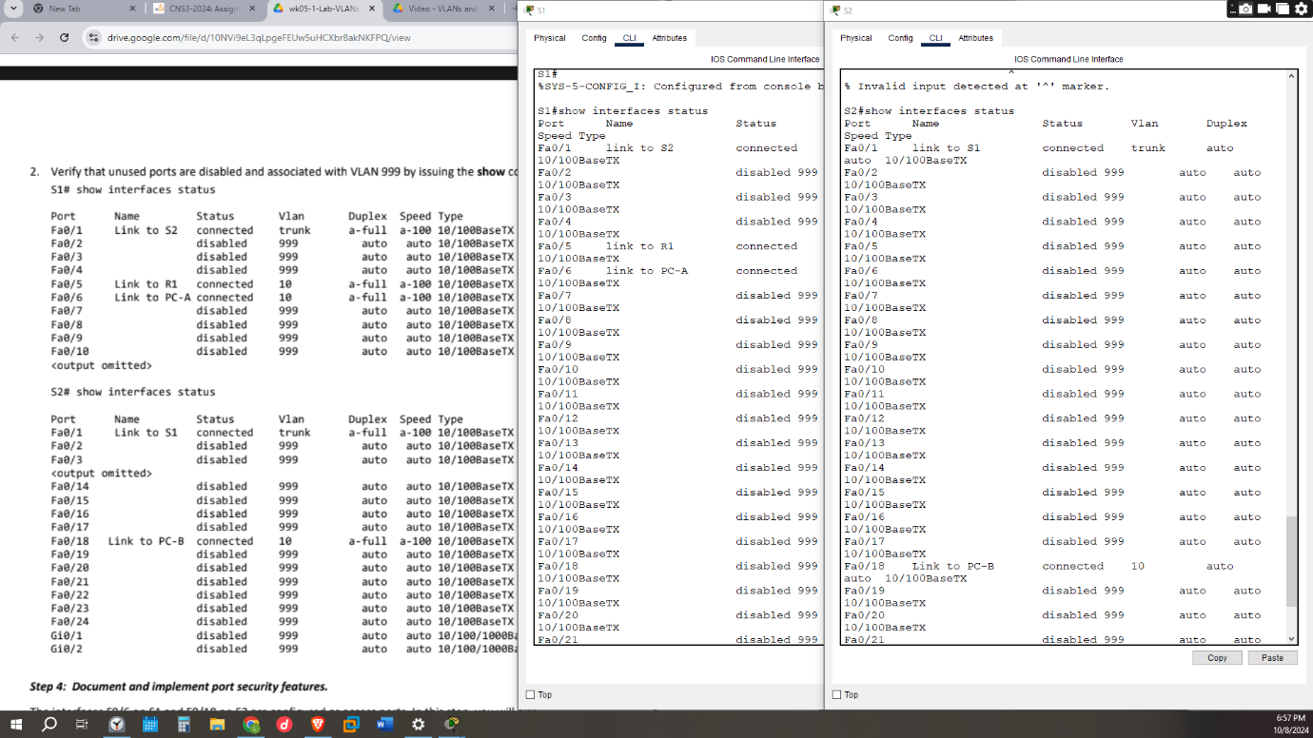

Step 4: Document and implement port security features.
The interfaces F0/6 on S1 and F0/18 on S2 are configured as access ports. In this step, you will also
configure port security on these two access ports.
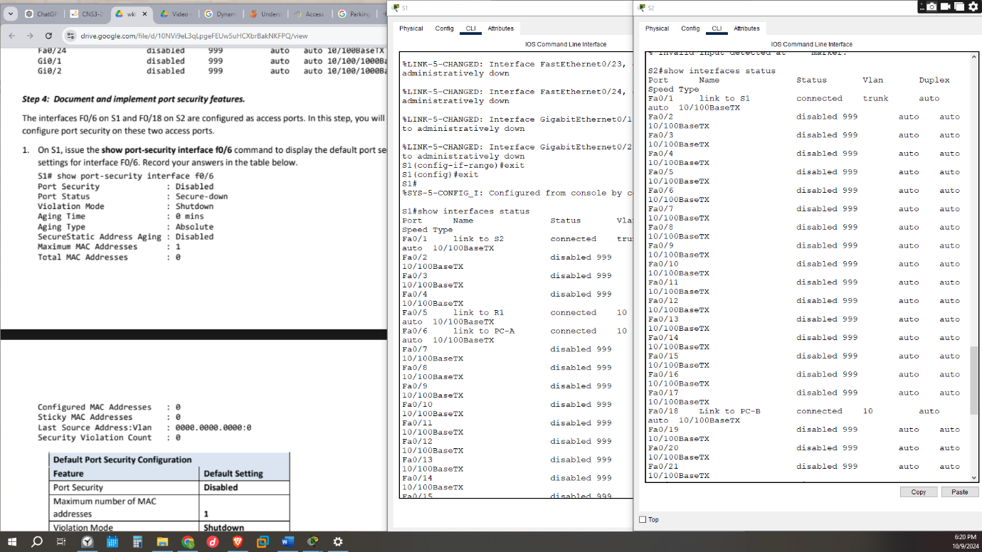

- On S1, enabling port security on F0/6
- Switchport port-security aging type inactivity- The inactivity aging feature prevents the unauthorized use of a secure MAC address when the authorized user is offline
- switchport port-security violation restrict-Restrict which discards the traffic and sends a SNMP message but keeps the port up reference https://www.cisco.com/c/en/us/td/docs/switches/lan/catalyst4500/12-2/20ewa/configuration/guide/conf/port_sec.html

Step 5: Implement DHCP snooping security.
DHCP snooping - is a security technology on a Layer 2 network switch that can prevent unauthorized DHCP servers from accessing your network protecting it from the untrusted hosts that want to become DHCP servers.
- On S2, enable DHCP snooping and configure DHCP snooping on VLAN 10.
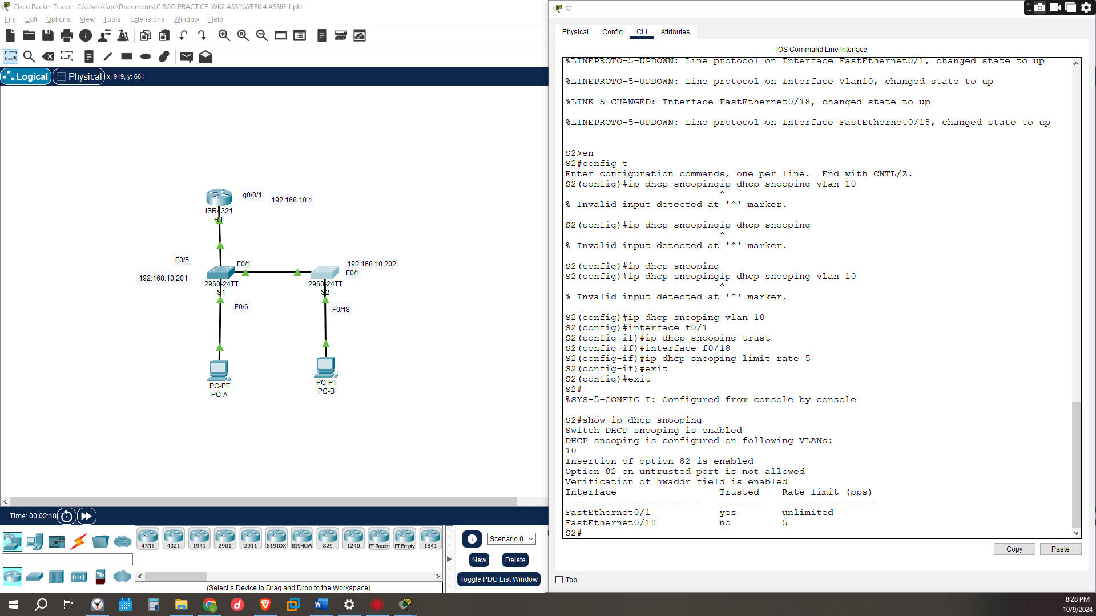

Step 6: Implement PortFast and BPDU guard.
Spanning Tree PortFast - is a feature in switches that allows a port to bypass the typical Spanning Tree Protocol (STP) states (listening and learning) and transition directly to the forwarding state
BPDU guard. - is a security feature designed to protect the active STP topology by preventing spoofed BPDU packets from entering the STP domain. would be applied to edge ports connected to end user devices that do not run STP.
Normal Spanning Tree Protocol (STP)- is a network protocol designed to prevent loops in Ethernet networks with redundant paths. STP is defined in the IEEE 802.1D standard and works by establishing a loop-free topology for networks with switches. Helps maintain a reliable Ethernet network by managing the forwarding and blocking of ports based on the topology.
- Configure PortFast on all the access ports that are in use on both switches.
- Enable BPDU guard on S1 and S2 VLAN 10 access ports connected to PC-A and PC-B.
- Verify that BPDU guard and PortFast are enabled on the appropriate ports.
show spanning-tree interface f0/6 detail
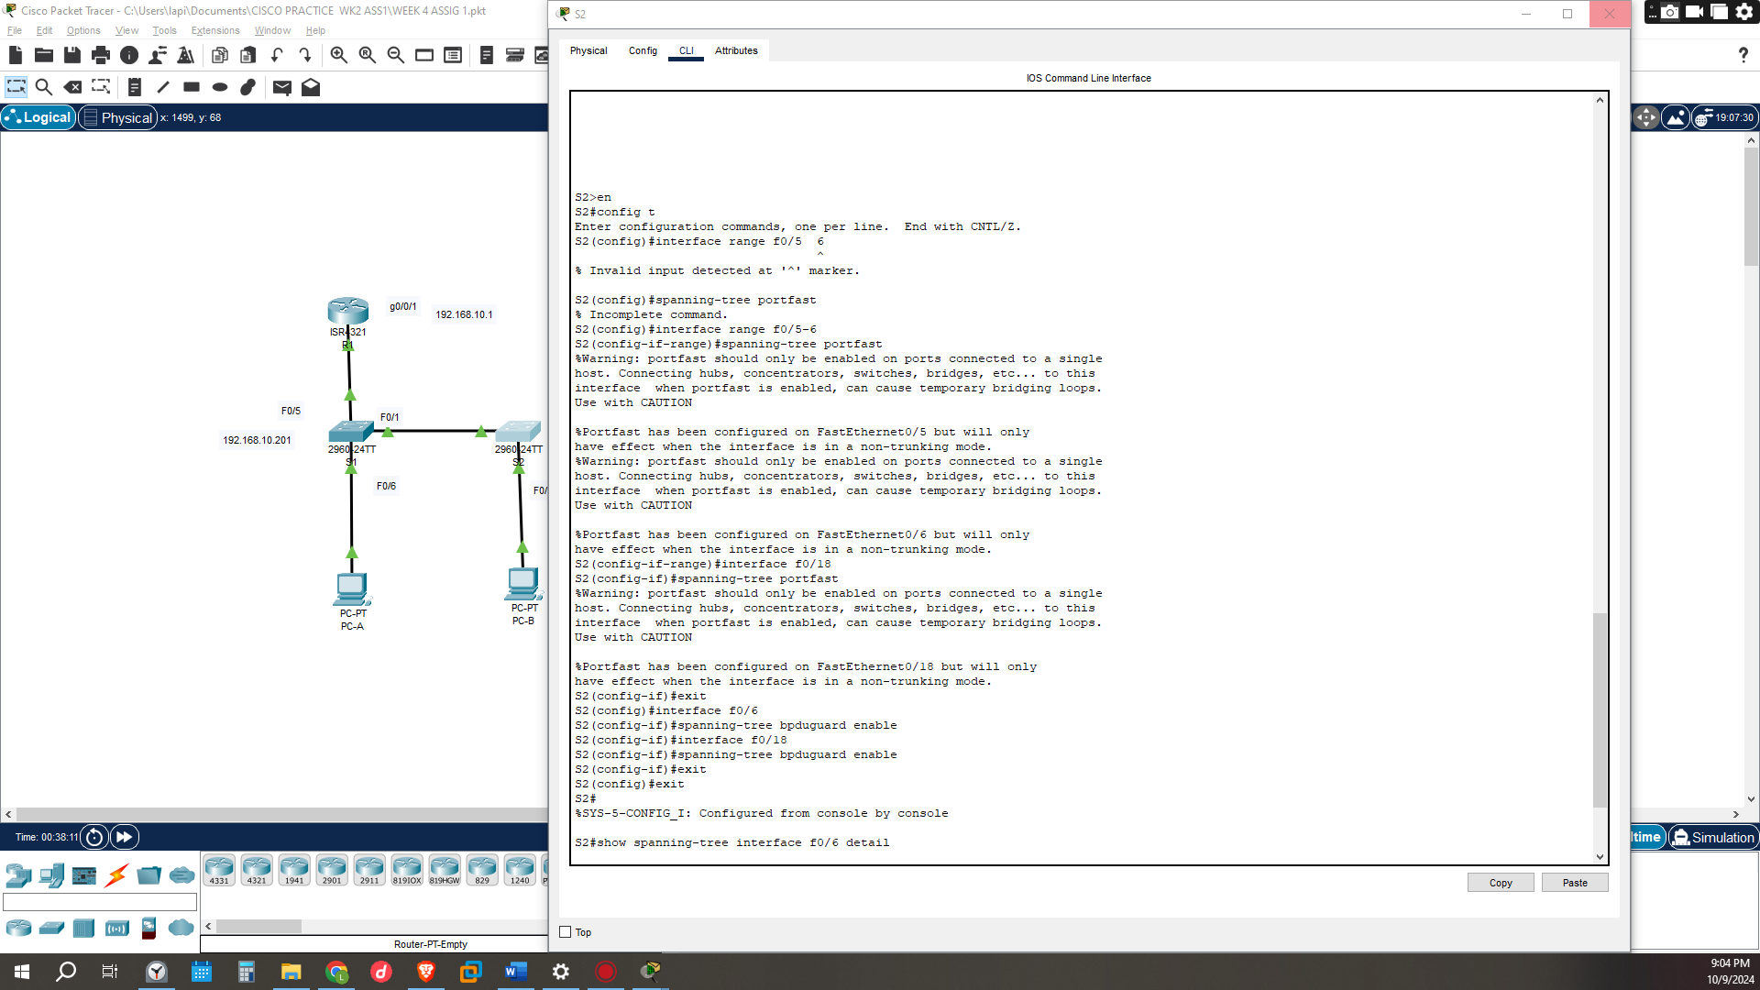

1. In reference to Port Security on S2, why is there no timer value for the remaining age in minutes when sticky learning was configured? This is because when sticky learning is configured the mac address learned on the port are retained thus, they are considered static but learned dynamically thus when regular dynamic mac address has a timeout period sticky learned addresses don’t expire
2. In reference to Port Security on S2, if you load the running-config script on S2, why will PC-B on port 18 never get an IP address via DHCP? Port security is set for only two MAC addresses and port 18 has two “sticky” MAC address bound to the port. Additionally, the violation is protected, which will never send a console/syslog message or increment the violation counter.
3. In reference to Port Security, what is the difference between the absolute aging type and inactivity aging type? Absolute aging type means all the secure addresses on this port age out at exactly the time specified while
In Inactivity aging type addresses age out only if there’s no data traffic for time period

CONCLUSION
From the exercise ,different networks can be created for different departments without them sharing each other resources by having them in different VLANs virtual; local area networks in the VLAN the switches can be configured in a manner of how they can be expanded to use more than one switch can have a way of each swich and the router connected to it to communicate using the trunk port having the data to be sent to the end user sing the access ports .Theres been a descriptions on the security setting on the switch ports and how to disable unused ports by storing in the VLAN 999 parkinglot

